State Examinations Commission Candidate Self Service Portal

The LC CSSP portal is open from now until 5PM on Tuesday 23rd February.

During this time Leaving Certificate candidates will be required to register and create their portal account, confirm their subject and level entry details, and add or delete subjects from the records presented to them

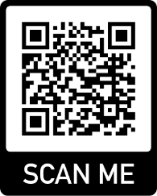
Access to the Portal

Leaving Certificate candidates should access the portal tonight at https://www.examinations.ie/cssp/2023/ or by scanning the QR code.

You will need:
· LC Exam Number which has been given to all students.
· Their PIN which is the 1st 4 numbers of their PPS number.
· An email address and mobile phone number which they will have access to over the coming months.
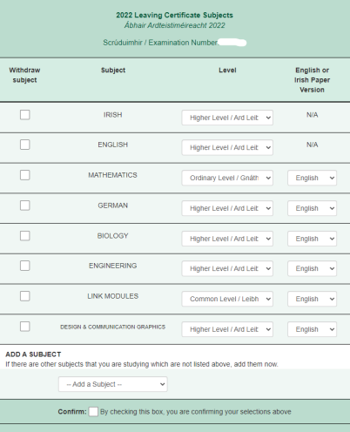
Once in the portal, students will have to select levels from the drop down menu as pictured. They can also add languages they are studying outside of school.

Selection of levels:

If students are unsure of levels they should discuss this directly with their subject teachers prior to confirming on the portal.

Additional Subjects – Languages

Candidates should only add their additional language as an extra subject, They should have spoken to their year head about this before adding the subject. No student should withdraw from a subject. Candidates will not be able to add additional subjects after the portal closes on 23rd February.

Enquiries
Enquiries should be sent by e-mail to entries@examinations.ie. There is also an SEC helpline available at 1800 111 135 or 1800 111 136 from 9 am to 5pm.

