Ardgillan College

Distance Learning Plan
2020-2021

Distance Learning Plan

2020-2021

Contents
Introduction 1
Key Considerations in Developing a Distance Learning Plan 1
TEL Team 2
The Results of the Student Survey 3
What type of device are the students using? 3
iPhone v Android 3
How many in this class, share your Remote Learning device with others at home? 3
How many know how to open your Office 365 email account? 4
How many know how to send an email? 4
Are you signed up to Edmodo or Teams for ALL your classes? 4
How many know how to contact your teacher via Edmodo? 4
How many know how to upload work to the 'Assignment' section? 5
How many have trouble viewing PowerPoints on Edmodo? 5
Do you know where to find teacher feedback on your work on Edmodo? 5
How many know how to use 'Genius Scan'? 5
How many have an Instagram account? 5
How many of you follow the Ardgillan CC News Instagram page? 6
How many of you follow the school's twitter page? 6
Are there any other major issues that this class had with online platforms and remote learning? 6
Any comments? 8
Summary of Findings 9
Results of Teacher Survey 10
What platform have you and your department decided to use for distant learning if required? 10
What platform will you use for live lessons? 10
How much feedback did you give on SENIOR student’s work online during school closures? 10
How much feedback did you give on JUNIOR student’s work online during school closures? 10
What were the challenges you found when giving feedback during remote learning? 11
Why did you give the feedback you did? 11
Did you use instant marking options such as Forms and Socrative etc? 11
Did you give homework after every lesson? 11
Is your homework usually due for the following lesson? 12
Do you check in detail, every homework activity given? 12
What device do you plan on using for your lessons this year? 12
Would you be interested in purchasing a new device such as a laptop etc. if the school were to bulk order through wriggle? ** Please note that this is not subsidized by the school. 12
What did you have difficulty with online that you would like more guidance on? 12
Overall, what would you like tutorials or guidance on to enhance your 'remote teaching'? e.g. Teams, Edmodo, live lessons etc. 13
What were the challenges you faced when giving feedback? 13
How did you give feedback? E.g. Typed out solutions, comments on Edmodo, Other. 13
What challenges do you face in your subject in relation to not having books in class? 13
What did you find worked best for you overall during remote teaching? 14
Any other comments, suggestions, issues with distance learning and the new set up? 14
Summary of findings 15
Parent Survey Results 17
What was your experience of Ardgillan’s Distance Learning Programme in your Home? 17
Home Environment 17
Communication and Feedback 18
Timetabling Concerns 19
Workload 19
Exams 20
Technology Issues 20
Parent Edmodo Account 20
Parent Suggestions 21
Communication 22
Distance Learning Communication 22
Internet Safety Education for Students 22
Wellbeing 22
Video Conferencing 23
Remote Learning 23
Academic Progress and Behaviour 23
Actions Taken as a Result of the Surveys 24
Edmodo Videos 25
Microsoft Office 365 Videos 25
Recommendations 26
Appendix 1: Edmodo Student Training 29
Appenix 2: Edmodo and Team Codes Insert for Student Journals 41
Appendix 3: Suggested checklist to support action planning for schools when pupils and/or teachers are advised to self-isolate or restrict their movements 43

Introduction

Key Considerations in Developing a Distance Learning Plan
Drawing on the experience of remote learning during the Covid-19 closure, the Dept. of Education (Circular 0074/2020) recommends that schools review their current position and learn from the approaches adopted to facilitate ongoing teaching and learning. This will assist planning for implementation of a remote learning approach as required. The review should assist schools to consider the following relevant areas:
- Understand its own readiness to support online and remote learning and how this would interface with and supplement in-school learning. The school should also provide an opportunity for teaching staff to review how remote learning worked during school closures and how this experience can inform contingency planning
- Identify CPD needs for teachers including
  - Raising awareness about where to access professional development (internally and externally)
  - Implement a professional development plan for teachers to support the chosen model for remote learning
  - Support students in understanding and learning how to use the adopted platform
- Identify the types of resources or supports needed that are not currently in the school
- Examine elements of the curriculum which require teacher led interaction and those which are more suited to consolidation in the remote learning environment ensuring that planning includes a clear outline on how technology will be used if remote learning is required
- Identify supports that students need
- Engage with support services for advice on online learning and communication platforms
- Determine if existing online learning platforms, in use in the school, can be expanded for further functionality
- Establish a peer-support group of teachers and of students in the school to support skills development for the adopted platform
- Ensure ongoing communication with staff, students and parents on updates and changes to features and functionality of the adopted platform as contingency measures are developed.

TEL Team
The first step in planning for an effective Distance Learning Programme was carrying out a survey of staff, students and parents. These surveys informed the next steps for the TEL Team, including training and developing procedures. This document details the feedback collected from these surveys and the actions taken by the TEL Team as a result of this feedback. The members of the TEL Team are:
- Caitriona Rooney
- Kim O’Toole
- Alva Cushen
- Joanne Collins
- Niall O’Connor
- 7 TY students

The Results of the Student Survey

On Wednesday 7th October 2020, 841 Ardgillan students completed a survey on Distance learning. This is the breakdown of the results of the survey:

What type of device are the students using?
Mobile Phone: 619
PC/Laptop: 431
Tablet/iPad: 126

iPhone v Android
iPhone: 395
Android: 216

How many in this class, share your Remote Learning device with others at home?
Shared: 144
Not Shared: 697

How many know how to open your Office 365 email account?
Yes: 721
No: 120

How many know how to send an email?
Yes: 663
No: 178

Are you signed up to Edmodo or Teams for ALL your classes?
Yes: 597
No: 244 (particularly the TY classes)

How many know how to contact your teacher via Edmodo?
Yes: 815
No: 26

How many know how to upload work to the 'Assignment' section?
Yes: 797
No: 44

How many have trouble viewing PowerPoints on Edmodo?
Yes: 296
No: 545

Do you know where to find teacher feedback on your work on Edmodo?
Yes: 358
No: 483

How many know how to use 'Genius Scan'?
Yes: 273
No: 568

How many have an Instagram account?
Yes: 643
No: 198

How many of you follow the Ardgillan CC News Instagram page?
Yes: 499 (78% of students with Instagram accounts)
No: 342

How many of you follow the school's twitter page?
Yes: 46
No: 795

Are there any other major issues that this class had with online platforms and remote learning?

Submitting Work & Tests | Assignments going up late
 | Uploading work very late in day.
 | Teachers can upload work late. Please send work at the beginning of the day. Sometimes there was too much work sent for a class.
 | Deadlines too close together. Found it hard to keep up. Internet issues at home restricting students from getting work done on time.
 | Notifications not working , teachers not putting up work on time/closing the assignment early
 | Documents would not load when you would send them. Often would say work was not submitted when it was. Trouble with work submitting. Devices would time out. Some documents from teachers would not load. Students would get notifications of work from teachers a few days later as opposed to when it was first sent.
 | Tests were very glitchy and they could not get into them on time. Summer exams did not work well, some had to write at a different time rather than doing the exam during the timeframe. Assignments often would not send on time. Assignments locking before they had a chance to do them - very varied rules throughout subjects. Sometimes no notification for assignments.
 | Locked assignments on edmodo means they can’t access test/assignments.
 | Teachers not posting work on time / regular / during the day .... a lot of work being posted in the evenings ,
 | Slow to be notified about assignments on Edmodo
 | Work sometimes posted late in the day. Work due for next day instead of next class day.
 | Troubles with uploading on Edmodo
 | Issues uploading photos onto assignments.
 | Technical issues with Edmodo - thought work was turned in but it wasn’t. Difficulty attaching screenshots of work. Work being posted in feed rather than assignments.
 | No notifications about work coming in, cant see teachers posts, uploading work but teacher wasnt getting it, trouble with office 365
 | Assignments won't load.
 | Insufficient time given to complete work. Some issues submitting work (fails to submit, without notifying user)
 | Work wont upload. Couldn't access assignment. No assignments appearing. Tests confusing. Pictures in assignment not loading.
 | Edmodo sometimes difficult to see/find assignments
 | Teachers not creating assignment boxes instead just posting the work in the page and making it difficult for students to see what assignments and work they had due.
 | 1. Teachers not setting work as an assignment on edmodo, only creating a post made it difficult for students to see what was due and when. 2. Links been given by teacher but when clicked on by students they needed permission to access.
 | Work uploaded for classes to late.
Technical Difficulties | Very difficult to view material uploaded by teacher when using a mobile phone. Some students have slow internet connections. Students are worried about getting in trouble for not uploading work, even if they do not know how to do so.
 | Wifi speed at home was an issue at times
 | Photos Loading on summer exams on office 365
 | eBooks sometimes didn't work. workload was a bit intense. internet problems. Submission boxes didn't work.
 | Internet not working. Big documents not loading or sending.
 | Poor internet.
 | Issues opening documents on phone. Invalid Edmodo codes. Can't open Powerpoints.
 | Poor quality internet at home was an issue,
 | Very hard to see when you were working on a phone.
 | wifi poor
 | Some students have issues with internet in their homes
Feedback | Not getting feedback on your work, learning the work ..
 | Delay in answering queries from teachers. Hard to find feedback for work.
 | Slow teacher feedback in relation to questions
 | never recieved feedback. some teachers didnt upload
 | Sometimes teachers took a long time to give feedback or correct work. No feedback from some teachers!
Edmodo & Microsoft Teams | Divide between Edmodo and Teams confusing/easy to miss work. Edmodo is more user friendly for students. On Teams it can be difficult to locate the work. App Vs Website.
 | Class consensus is they don't like teams and Edmodo is slot more user friendly and simpler. On teams some report file wouldn't open properly on phones.
 | More confident on edmodo then teams
 | This class expresses preferences to use Edmodo. No Teams. Edmodo is easier and more efficient.
 | Office 365 wouldn't work for one student. Multiple students had to make multiple Edmodo accounts after forgetting passwords or locking them out.
 | Students do not know how to use teams and would like to be shown how/training. Students would like to be able to practice using teams in the computer room.
 | Some students said Edmodo crashed on several occasions. Sometimes word document wouldn't open
 | Edmodo crashes sometimes.
 | Don't know how to use Teams. School email address doesn't work. Can't join anymore Edmodo classes.
Teaching & Learning | Didn't like it, didn't do it, couldn't work it.
 | the class don't feel they actually know the material that was "covered" online.
 | More work that typically done in class. Understanding the work. Most of work spent reading/writing, would be nice to mix it up.
 | Students who are out are saying that teachers for some subjects are not putting up work for the class content. They also said some teachers are putting up on edmodo contuine work from class, but students who are absent dont know what to do as they where not in the class. They want all work and notes put up for each class.
 | Not enough explanation, just written work.
 | Workload was a lot on some days to be done for one day
 | Some found that there was an overload of work and homework. - found this difficult to keep up with . Some found it challenging to understand certain subjects - maths & English. Some others found self learning difficult. Some teachers gave work to students on days they did not have that subject and also uploaded the work late at night.
 | Needed to hear a teachers voice explaining, needed to hear a voice explaining for maths, video recording was good. Doesn’t have to be live. Not enough time to finish because given the same day. More work than if you were in school.
 | Some teachers posting too much work for example, an hours work rather than 40 mins. Lack of schedule & hard to stay focused without teachers help 5. Teachers not posting work at class time (later in the day or even in the evening) and students would be working until night time as a result. 6. Harder to learn by doing work. Would rather zoom calls). When moving onto new topics really confused and not understanding through notes.
 | Teachers giving work when They did not have that specific class on that day
 | Teachers not messaging back during school hours
 | some had to do summer exams twice, genius scan don't like, were expect to print documents and hadn't easier if all staff used the one platform this facility
 | Not motivated when learning at home. Working to timetable at home and scheduling work. Teachers taking too long to reply

Any comments?

- Students would like a class where they learn how to use platforms properly.
- Parent - teacher communication needs to be clarified i.e. how does a parent contact a teacher directly if a student wants to change levels
- Stick with Edmodo if possible. Training on iPads especially Teams would be appreciated. Training on attaching files as word documents don't always open properly.
- Thank you :)
- Overall the class feel very nervous and not prepared for online learning.
- Video explanations are more effective; voice notes better when further clarification needed. Work not always posted on time. Socrative is more efficient than Forms.
- Easier to learn in class face to face think it would be a good idea if option for everyone to but laptop same brand at a discount would have been easier everyone using the same

Summary of Findings

- Most students are using their phones for Remote Learning (57% of those surveyed). This has a number of implications. First of all, this makes viewing certain documents difficult – Powerpoints, Word documents, pictures etc. Also Microsoft Apps that require a lot of storage will not run on certain phones. Edmodo requires less storage and works on all smart phones.
- The student survey indicates that Edmodo is the best option as a Remote Learning Platform as it runs on all smart Phones and the vast majority of students are happy with the interface.
- Wifi issues is a problem for some students. For this reason, work should be assigned at 8.30am and the student should be permitted 24 hours to submit the work.
- Students do not know how to access Feedback and in some cases upload Assignments. There is a real need for student Training in Edmodo and Microsoft 365.

Results of Teacher Survey

Between Friday 4th September and Monday 7th September 2020 , 48 Teachers responded to the TEL Team’s survey on the teachers’ experience of remote teaching and learning. This is the breakdown of the survey results:

What platform have you and your department decided to use for distant learning if required?

What platform will you use for live lessons?

How much feedback did you give on SENIOR student’s work online during school closures?

How much feedback did you give on JUNIOR student’s work online during school closures?

What were the challenges you found when giving feedback during remote learning?

Why did you give the feedback you did?

Did you use instant marking options such as Forms and Socrative etc?

Did you give homework after every lesson?

Is your homework usually due for the following lesson?

Do you check in detail, every homework activity given?

What device do you plan on using for your lessons this year?

Would you be interested in purchasing a new device such as a laptop etc. if the school were to bulk order through wriggle? ** Please note that this is not subsidized by the school.

What did you have difficulty with online that you would like more guidance on?
- Correcting & feedback
- Time Management
- Lesson Preparation
- Making lessons more interactive
- TEAMS training
- Live Lessons/Voiceovers etc.

Overall, what would you like tutorials or guidance on to enhance your 'remote teaching'? e.g. Teams, Edmodo, live lessons etc.
- Live Lessons
- TEAMS
- Voiceovers

What were the challenges you faced when giving feedback?
- Heavy workload
- Time- Huge amount of time spent planning, correcting, feedback etc.
- Student work is difficult to read
- Students not acknowledging feedback
- Students answering in different areas of the platform

How did you give feedback? E.g. Typed out solutions, comments on Edmodo, Other.
- Comments on Edmodo
- Typed out answers/feedback
- Verbal feedback in Live lesson
- Video demonstrations & students self-correct.
- Solutions posted online

What challenges do you face in your subject in relation to not having books in class?
- Can’t let students work ahead
- Thinking of new ways to deliver content
- Workbook questions done for homework and not being in class to correct.
- Losing sheets
- Language classes difficult as they can’t follow along.
- Setting work/class exercises
- Maths-Can't check their own answers
- Aural work is difficult
- Text heavy subjects (e.g. History & English) rely on books for a lot of lessons.
- Student focus can drift without their own materials
- When the internet is down, books were the option to turn to.

What did you find worked best for you overall during remote teaching?
- Edmodo
- Videos
- PowerPoints with voiceovers
- Live classes
- Padlet
- Routine/Consistency
- Uploading work in the morning-full day to plan/correct/answer questions
- Instant feedback quizzes/Socrative

Any other comments, suggestions, issues with distance learning and the new set up?

If we were to be distance learning again I would like for a distance learning timetable to be drawn up in which we had longer classes but less class groups every day so that we could give our best focus on each group
Air server - how does it work?
Fear that students will not engage again if we go to distance learning. Also getting students who did not engage last year to catch up. We done key components of the course that are definite questions on the paper.
To potentially do training sessions for staff on teaching effectively during a pandemic and online distance teaching/learning strategies that teachers could implement.
Lobby DDLETB to stop blocking northerners out of teams and outlook. If this fails my VPN is working for now. It makes DDLETB think I'm logging in from the south but may not be an option for all northern teachers.
Would much prefer live lessons to all year groups
Students not knowing how to use outlook and their email.
Training for students. Class teachers don't have time to guide every class through set up and uploading assignment questions. This could be done once by the tutors.
A systematic way of sharing resources for online learning (and not just on an individual teacher-to-teacher basis)
A scheduled timetable is very difficult for most students to follow when working from home. I think it's better to record lessons which can be posted on an online platform. I also think daily homework is too difficult and that project-based learning was very successful instead.
I'd like a better understanding of digital resources and platforms I feel I was restricted because I didn't have the tech know how.
It would be great for students to be trained on how to use Teams and also for teachers, like me, to get some extra training on voice over PowerPoints, videos, and teams live lessons.
I’ll be using OneNote this year for class work so that it is visible to anyone who is absent.
Just will struggle for languages when trying to fit oral, aural, reading and written into each lesson. Will lose a lot of time with students having to take everything down of the board.
Weekly feedback.
Online homework quizzes.
Whatever we decide on for educational platform, training needs to be provided for staff and students and might be no harm having a guide booklet that can be referenced at home if students are struggling.
I would like a HDMI cable so I can connect my own laptop to projectors, it would be considerably faster than using the class computer with keyboard etc.
I think students need to be trained on Edmodo so they can access their feedback. I don't think every student knew how to go into the comments on their assignment and read their feedback.
Lack of portfolios/workbooks to support independent learning in class.
Get everyone set up now while we can
I would like ideas on how to give feedback quickly and effectively, like I would in a classroom by walking around the room and having chats with students.
Need face to face contact with students in order to check their understanding of a language.
Never sure learning work is being done with distance learning.
I haven’t done online teaching yet
I would like projectors to be HDMI enabled so I could just connect my own laptop. Plugging in own keyboards etc and logging on takes too much time.
Ways of making videos at home if it so happens online teaching occurs again.
Guidelines on what to do with students not participating. Spent at least 30 minutes everyday checking who had completed work and emailing their year heads back and forth which became frustrating
- In relation to the new set up, I feel that it should be a common platform used by all e.g Edmodo/ teams for consistency.
More IT training across platforms
More training on teams
Needs to be time specific
I think that teachers should be supported with the provision of laptops should distance learning become a regular occurrence.

Summary of findings

- Teachers mainly used Edmodo from March to June 2020.
- They intend to use Edmodo going forward.
- They would use TEAMS for live lessons if training was provided.
- Teachers would like students to be trained on Edmodo.
- Workload and time were the main issues faced by teachers.
- Feedback was given but not as much as teachers wanted to give -Time & Workload were the issues with feedback.
- Images uploaded by students could be difficult to read.
- Voiceovers and live lessons worked well during remote teaching & learning.
- 25/48 teachers would be interested in purchasing a new device (Sept 2020)

Parent Survey Results
On 15th October Parents of students in Ardgillan College were requested to take part in a survey on their experience of Ardgillan's distance learning programme during school closures from March to May 2019. A total of 193 parents responded to the survey.

What was your experience of Ardgillan’s Distance Learning Programme in your Home?

In response to this survey, the majority of parents indicated a positive experience and expressed their gratitude.
Those that indicated an ‘Ok’ experience was as a result of home environment issues and issues which should now be resolved after student training which took place in the College during October 2020.
A small percentage of parents (13%) expressed a negative experience, stating difficulties around motivating students or expressed concerns regarding lack of communication or consistency. A lot of parents indicated difficulties with getting students motivated and engaged, particularly towards the end of remote learning.

Home Environment

Many parents in their responses identified the following as positive and negative contributory factors to their experience of distance learning.

What Worked Well/ Recommendations for Home Environment set up | Difficulties
- Beginning work at 8.20 in morning  - High speed broadband  - Designated space to do work.  - Each student having own room, device e.g. Ipad and desk each  - Parent off work at time- could provide support  - All students had laptops and desks in their rooms so they were able to work as normal in their own quite space. | - Poor Wifi  - Parents/Guardians working from home also  - Not enough devices for all working from home  - Very stressful trying to figure out Edmodo, uploading work etc,  - Self-directed learning, self-organization and Getting student to structure their day  - Expectation that parents could teach & be available in the home to support when parents were also working  - Hard to concentrate  - Difficult home life circumstances – siblings with additional needs.  - Hard work for parent  - Mental health concerns  - Monotonous feeling to a lot of the online classes, rewriting of notes, no feeling of a sense of belonging to the school

Communication and Feedback
Many parents expressed a positive experience in terms of communication:
- Teachers were superb at helping with questions
- There was good two-way communication.
- Liked the capability of messaging teachers with questions (This feature might need to be communicated to all students more clearly as other responses indicated that students had no ability to ask questions to teachers on work)
- Impressed with how quickly the school initiated it and the communication between teacher and pupil and parent
- Appreciated the personal and positive comments from teachers.
- Good oversight by management too.
- Appreciated the phonecalls home re missing work and check-ins. Well-being was just as important as subject matter

There was a mixed response from participants in terms of feedback:
- Feedback and replies from teachers were slow, lack of assistance.
- Some didn’t reply at all to messages.
- No feedback given even though students submitted work to deadlines
- No acknowledgment
- Lack of correspondence from the school in relation to level of work and quality of work.
- Parents need reassurance that better measures for parent teacher communication will be developed and implemented should distance learning be reinstated.
- Lots of encouragement was given from teachers. This helped given the challenge of working alone.
- Communicating directly with teachers was helpful.
- Many teachers helpful and quick to reply

Timetabling Concerns
Timetabling issues was a key concern for parents.
- Parents experienced difficulties getting students to engage as a result of ‘Lack of routine’
- Students did not have discipline and sign in at 8.30 and out at 3.30.
- The official timetable should have been followed with students logging in according to it.
- Teachers did not give work at correct time, resulting in students working late into evenings.
- Concerns expressed with teachers posting work night before, early in day, arriving late in the day, work sent after official school hours, work sent sporadically, class times overlapping.
- Some parents did not appreciate so much work arriving at same time.

Workload
Mixed opinions were expressed by parents on workload. It appears the workload was not consistent with all subjects.
Some felt their child wasn’t getting a lot of work or that it wasn’t taking very long while others felt they had a lot to get through and finish for next day. Many were happy with volume of work and felt teachers were realistic with workload and appreciative with the level of guidance, reassurance and support received from all teachers.
Teachers should post enough good quality work that should take the students 30 minutes to complete correctly and effectively.

Exams
Many parents expressed difficulties with the Exam Process. Exam results were not in line with previous in school results.
- Missed links/communication about different portions of exams.
- Tech issues resulted in answers being lost (students copied and pasted work into word document to avoid losing work prior to refreshing)
- Huge amount of anxiety for students about online exams
- Students felt deflated after Multiple Choice Questions even though a lot of study was done prior to exams.
- Didn’t get a sense of self achievement after completing exams and results didn’t reflect time and work that went into studying.

Technology Issues
Many parents expressed difficulties implementing Ardgillan’s Distance learning programme due to technological issues at home.

Parent Edmodo Account
Many parents indicated the Parent Linked Account was beneficial in keeping up to date with student work.
- “It was also great that you could see what the teachers were asking the students and if the work was completed”
- “ I found edmodo good because I could track when items were due but there sometimes was a delay when I would ask him was it submitted and it might not be up on system. Might have been a lag on his side”
- “…Edmodo alerts to parent phone were really useful…”
This feature should be clearly explained, demonstrated and recommended to all Parents as it will help resolve some issues identified by Parents
Examples
“ I found it hard to know what exactly she was doing as I am not familiar with Edmodo myself”
“I Found it difficult to see what hadn't been done in the subjects section so ….. got away with not doing a lot of it when I thought she had it done. I'm sure if it wasn't handed in I would have been notified so overall was happy with online”

Parent Suggestions
The survey provided parents with the opportunity to provide suggestions to help improve the experience of distance learning at home. The following suggestions were made:
- Live Lessons

- Help students ask questions and get immediate response.
- Interaction with teacher and peers would be beneficial for understanding and mental health purposes while providing a sense of belonging.
- Help keep students focused and on task.
- Help ensure students follow timetable if they have to sign in for live classes.
- Students that did not log in could be marked as Absent from classroom.
- Too much text and comprehending- live lessons, audio visuals on powerpoint were very helpful and appreciated.

- Timetable Requests
- Teachers need to post work according to timetable
- Lessons need to take length of time of classes
- Ensure deadlines are communicated clearly and are fair to student’s home circumstances
- Work only posted during school times

- Parents requested Feedback on Child’s progress
- Parents should set up parent account to monitor child’s progress, work submitted and feedback.
- Provide an email address for parents to contact teachers with queries.
- The college will continue to send term reports and communicate with parents where necessary if student is not submitting/ engaging with work online.

- Student training
- Emails, Office 365 (T&L Tab on website), How to submit work (T&L Tab on website), Training re how to contact/communicate with teacher (T&L Tab on website), Explain to parents how to help students (show where training videos are).

Communication and Support

Distance Learning Communication
The teacher, student and parent surveys all underline that good communication is key to a strong Distance Learning Programme. Ardgillan College continued to have very clear and open lines of communication with staff, students and parents throughout the distance learning process.
- Parents are informed of every policy and procedure enacted by the school so that home and school are working in collaboration with each other.
- The school website and social media platforms are constantly updated with important information required for the school community.
- During remote learning, our Special Needs Assistants rang every single student in Ardgillan College to check on how they were doing and if they needed anything from the school.
- Year Heads were also in constant contact with whole year groups and individual students, especially if those students were struggling with remote learning or not engaging with their teachers.
- Management and staff are in constant communication through email or virtual meetings via Microsoft Teams.
- Niall O’Connor and Caitriona Rooney attend weekly meetings with other DDLETB Post-Primary Digital Leaders in the DDLETB Digital Leaders group.

Internet Safety Education for Students
- As part of our SPHE programme our students learn about safe and ethical use of the internet and Cyberbullying.
- We hold an Internet Safety Week in the school, which is an internet safety initiative focused on raising awareness of online safety issues and good practice among students, parents and teachers.

Wellbeing
- Our Headstrong/ Amber Flag Team have run several initiatives to encourage students to develop self-management and organisational skills so they are equipped to balance in-school and remote learning.
- Our Headstrong/ Amber Flag Team have run several initiatives to raise awareness about Positive Mental Health and establish a supportive caring school environment both remotely and in-school.
- Our SPHE and Wellbeing programmes educate our students on the importance of diet, exercise, rest, organisational skills and stress management for mental health in the context of Distance Learning.

Video Conferencing
- All our staff meetings are now held on Microsoft Teams, in line with Covid-19 recommendations for schools from the DES.
- Parent information evenings are held on Microsoft Teams.
- The increase in video conferencing has put extra demand on our school Internet bandwidth. The TEL team are working closely with DDLETB and the PDST to improve the capacity of the Internet in the school and increase the bandwidth to 200MBs.

Remote Learning
Ardgillan has developed and adopted a model for learning that will support continuity of education regardless of inability of a class group or student to attend school due to Covid-19 specific regulations and recommendations.
- Homework is posted on Edmodo or Teams every school day so that students who are not in school can access school work.
- We have a dedicated team of teachers that develop a programme of work and organise Microsoft Teams live teaching for students who are unable to attend school due to Covid-19.

Academic Progress and Behaviour
Parents have each been assigned a secure Ardgillan VSWare login so that they can access the following information about their son(s)/ daughter(s):
- Timetables
- Attendance and Punctuality
- End of Semester Reports
- Behaviour Reports

Actions Taken as a Result of the Surveys
- The TEL Team organised that a HDMI connection be installed in every classroom so that Teachers can connect their own laptops or tablets to the projector without using AirServer, which requires logging onto the PC. This addresses the issues with logging onto multiple PCs as teachers move from classroom to classroom, which emerged from the Teacher Survey as concern for many teachers in Ardgillan.
- The TEL Team tested different methods of acknowledging student work and giving students feedback on Edmodo in an efficient and simple manner. This trial informed the development of instructional videos for students and teachers. The parent, teacher and student surveys all raised the issue of feedback. The student survey revealed that 57% of students do not know how to access feedback on Edmodo. This is the source of many of our issues with feedback.
- The TEL Team are in the process of producing a series of videos for teachers to explain features of Edmodo and Microsoft 365 that will make Remote Teaching more manageable and enhance the experience for students. The teacher survey revealed that teachers would like Training in Edmodo and Microsoft 365.
- Teachers have been informed of various training opportunities relating to Distance Learning and digital technologies. Several teachers have taken part in this training to date.
- The parent, student and teacher surveys showed the need for student training. On Wednesday 14th October 2020 Edmodo Training was delivered to all the students present in Ardgillan that day (Appendix 1). As part of that Training the students filled out a form with all their Edmodo class codes that is to be kept in their journal (Appendix 2).
- Every student was given a sticker with their Microsoft 365 login details. Students were instructed to put that sticker inside their journal in case they forget their password.
- The TEL Team produced a series of videos to demonstrate to address the areas that students are having technical difficulties with that were raised in the student and parent surveys. These videos are available on our website and the students were shown where to find them in their Remote Learning Training session. Additionally, to make parents aware of our series of support videos, the TEL Team sent an email to all parents to let them know where to find them. Videos can be accessed under Teaching and Learning Tab on Ardgillan College webpage. https://www.ardgillancc.ie/teaching-learning/student-tech-support
This is the list of videos at this moment in time (21st October 2020) and the TEL are continually adding to the series as issues arise:

Edmodo Videos
How to download the Edmodo App on an iPhone https://youtu.be/YDVq7BKwAEk

Getting your settings right on Edmodo https://youtu.be/Oe3saWFL9m0

Logging into the Edmodo App https://youtu.be/qpzu2DezH5Q

How to join an Edmodo class on Android https://youtu.be/sAbEpCsHHXY

How to contact a teacher on Edmodo https://youtu.be/5znaIsCM7HE

How to submit an assignment on Edmodo using an Internet Browser https://youtu.be/cB7K9JaINYg

How to use the Edmodo Backpack https://youtu.be/G6gIb2dWXEA

How to open Office 365 documents in Edmodo https://youtu.be/xGRLUflHcJQ

Microsoft Office 365 Videos
How to log into Office 365 using an Internet Browser https://youtu.be/mLl68EdMMFk

How to open Office 365 documents in an Internet Browser https://youtu.be/LFCqsfJOVxQ

Saving a document to your OneDrive https://youtu.be/qx6Htc6DVos

How to access OneNote through Microsoft Teams https://youtu.be/YiCMu7_-1c4

How to access OneNote on an Internet Browser https://youtu.be/iPBGLG5CIZQ

How to find class notes in OneNote https://youtu.be/GWq8B3Bha7Y

How to upload photos to the homework section in OneNote https://youtu.be/iCd9Zivi_v4

How to take clear pictures with the Office 365 App https://youtu.be/tFE0zSir5-g

Different ways of scanning pictures in Office 365 App https://youtu.be/2y5LbiDwvwo

Recommendations
This table outlines some simple steps that parents, students and teachers can take to resolve most of the issues that were mentioned in the surveys.
Issue | Teacher Solution | Student Solution | Parent Solution
Photos not uploading properly. | Upload as PDF | Use Genius Scan
Opening docs. on phones | Upload as PDF
Difficulty opening PowerPoints | Upload as PDF | Download Office 365
Workload was intense.  Insufficient time to complete work.  Assignments closing early/locking  Deadlines very close together  Work due for next day, not next lesson | Work should be assigned at 8.30am and the student should be permitted 24 hours to submit the work.  The work for students should be approximately 30 minutes including teacher instruction.  The TEL Team recommend teachers use the scheduler feature on Edmodo to ensure your work is assigned at 8.30am. | Work to your timetable | Try to encourage your child to begin school work at 8.30am and finish at 4 at the very latest.
Not enough teacher instruction | Voiceover PowerPoints, Videos & lives. Teacher Training will be provided.
Work posted as feed, not assignment | Post all work as assignments | Check your backpack at 8.30am
Issues with Feedback for students and teachers | Use Edmodo badges as an efficient way of giving feedback and give at least one piece of written feedback per week to ensure students receive feedback on all of their work. | Look at the video posted to the school website about accessing Feedback in Edmodo | Parents can set up a parent Edmodo account- this will allow them to see teachers messages/posts and feedback.
Forgetting their Edmodo passwords & making new accounts | Ensure the students have the correct Edmodo codes in their journal | Check your Edmodo codes with other students in your class. Look at the video posted to the school website about what to do when you forget your password for Edmodo
Work being submitted but teachers not receiving it |  | Look at training video on our school website on uploading assignments
Edmodo notifications not working | Refresh Edmodo page regularly | Refresh Edmodo page regularly
Too many platforms of communication | Edmodo is the primary platform for assigning work.  Microsoft Teams is to be used for live lessons.  Students and teachers can be contacted directly via email and only during school hours. | Students have a sticker in their journal with their email address login details.  Students have an insert with all the codes for each subject in their journal. | Take a picture of the email sticker and Edmodo codes in case the journal is mislaid.

In consultation with senior management, the TEL Team makes the following recommendations for a successful Distance Learning Programme in Ardgillan:
- Edmodo is to be the primary platform for assigning work in Ardgillan. Work should be posted and uploaded as assignments.
- Microsoft Teams is to be used for live lessons.
- Students and teachers can be contacted directly via email and only during school hours.
- Work should be assigned at 8.30am and the student should be permitted 24 hours to submit the work. Students should work to the timetable. Parents should try to encourage students to begin school work at 8.30am and finish at 4pm at the very latest. The TEL Team recommend teachers use the scheduler feature on Edmodo to ensure your work is assigned at 8.30am.
- There should be some form of teacher instruction in every lesson. Some examples of effective remote teaching methods from our staff:
  - PowerPoint with a voice over
  - YouTube videos to demonstrate a skill
  - Live lessons on Microsoft Teams
- The work for students in each class period should be approximately 30 minutes including teacher instruction.
- Teachers can use Edmodo badges as an efficient way of giving feedback and teachers should give at least one piece of written feedback per week to ensure students receive feedback on all of their work.

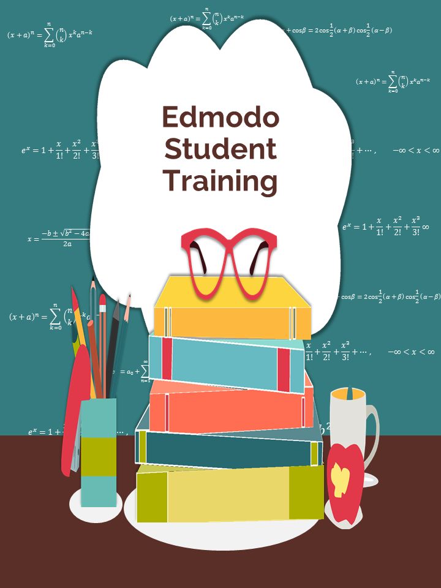
Appendix 1: Edmodo Student Training
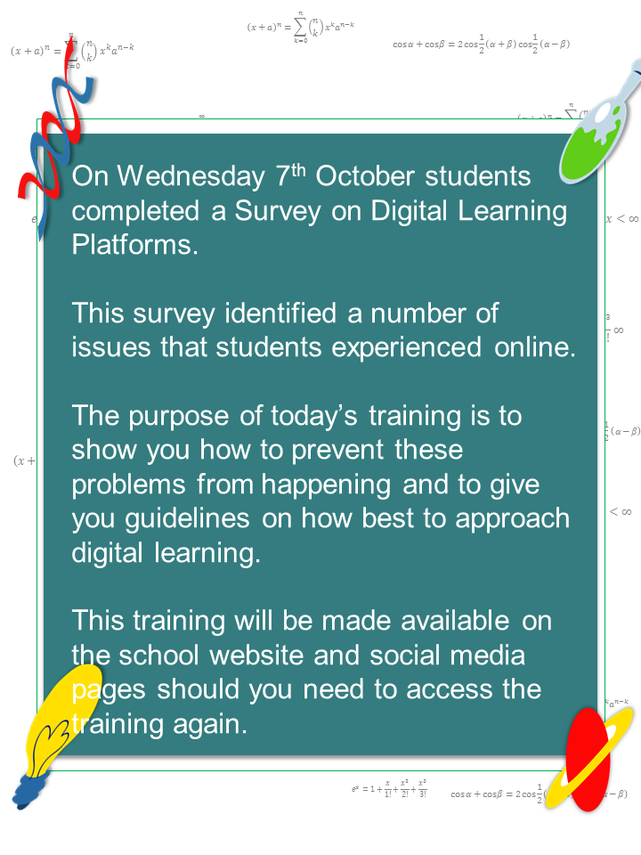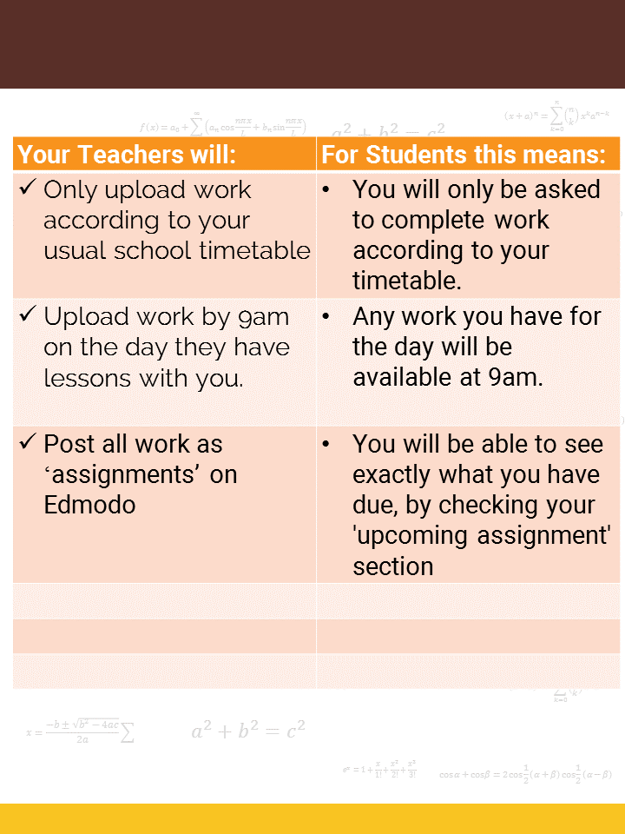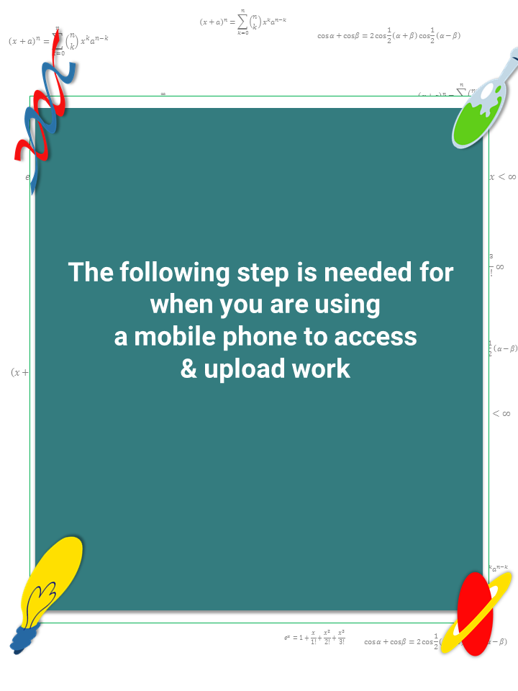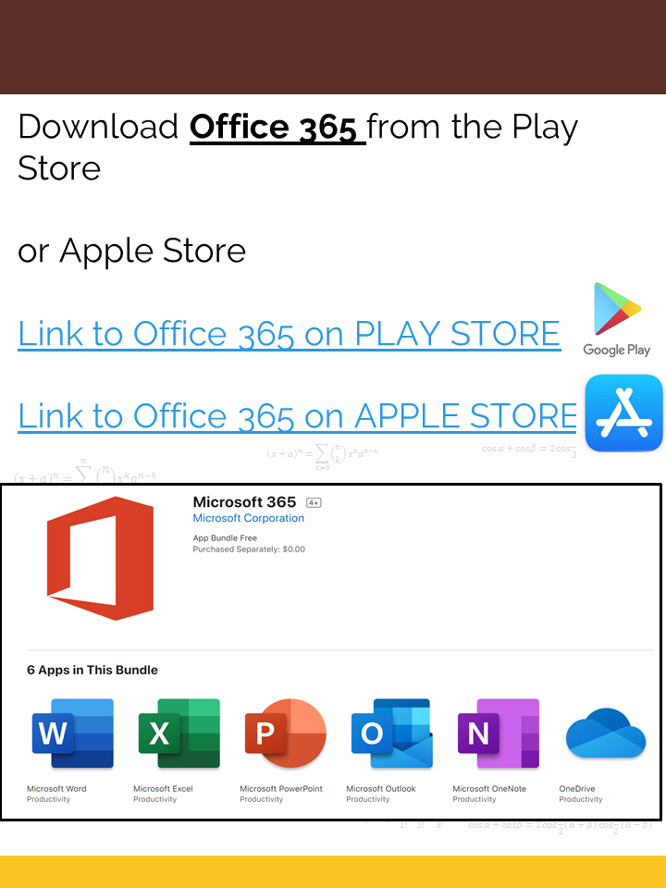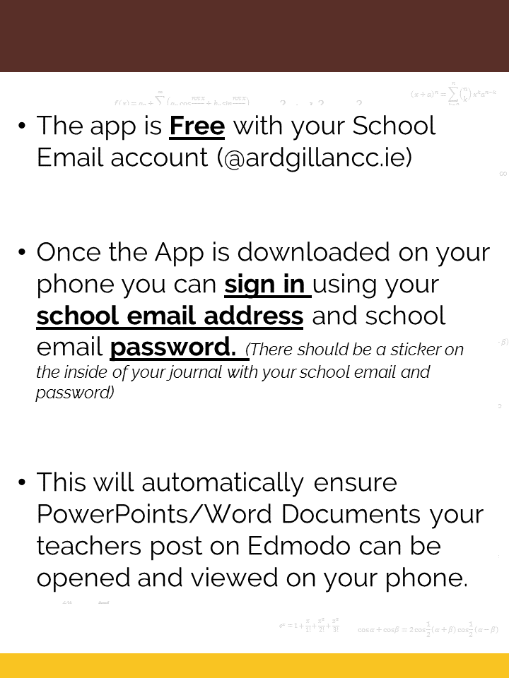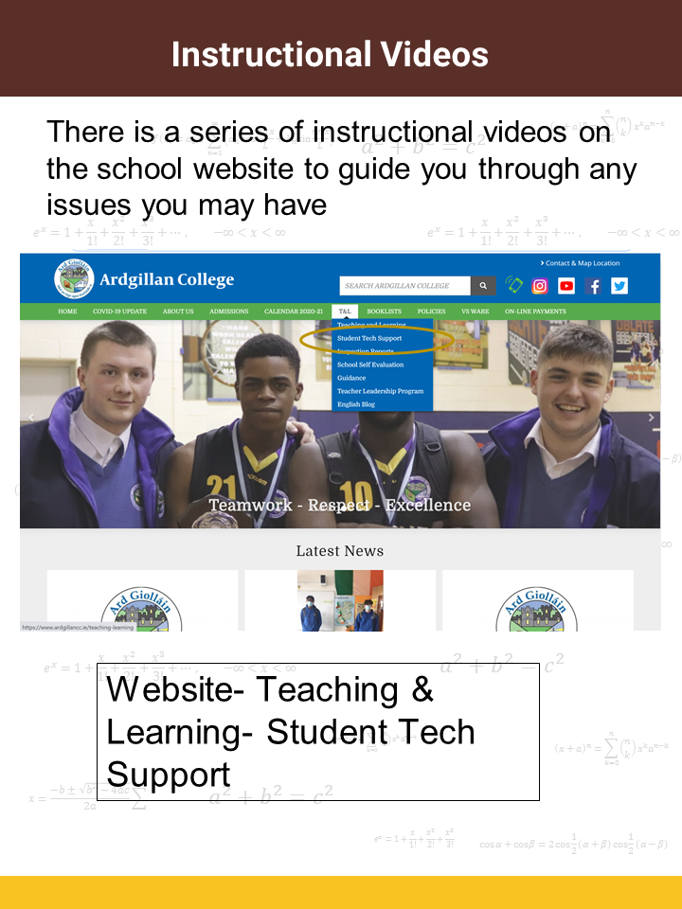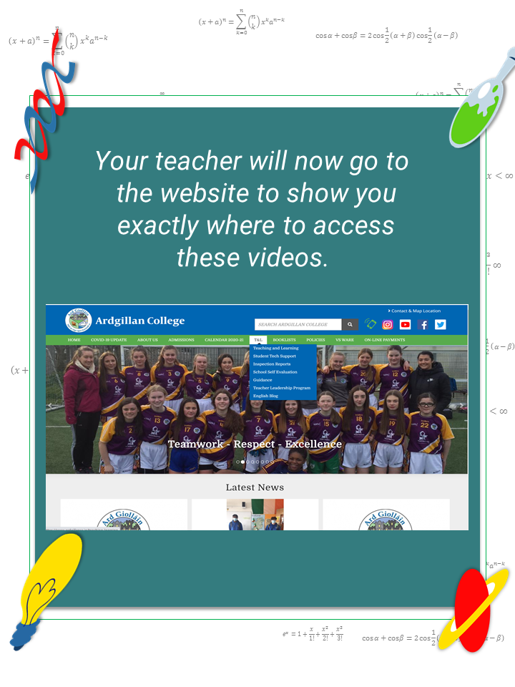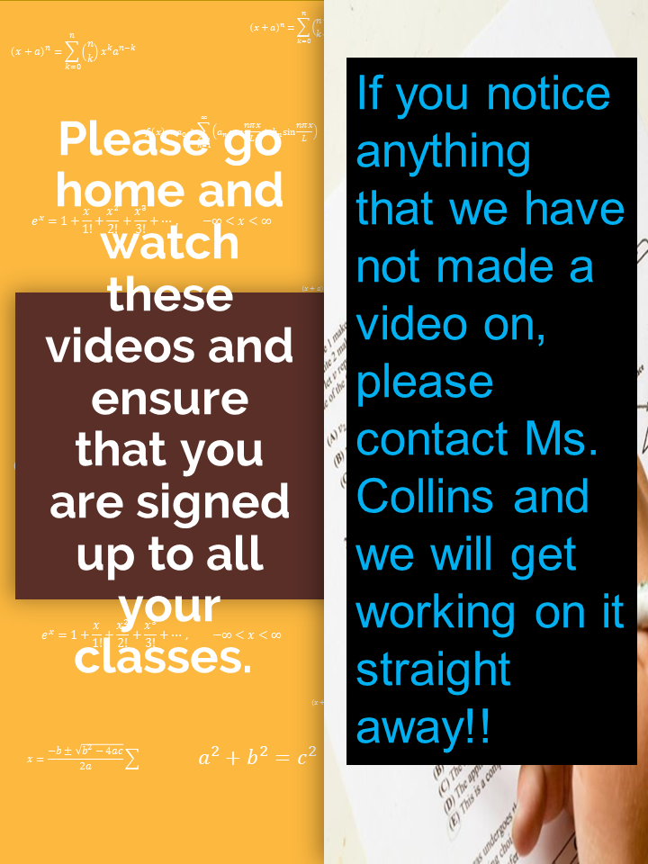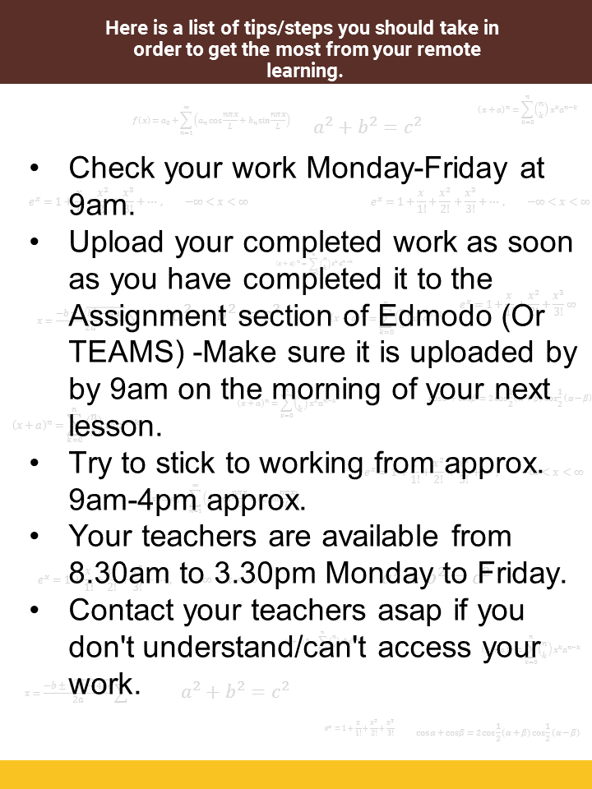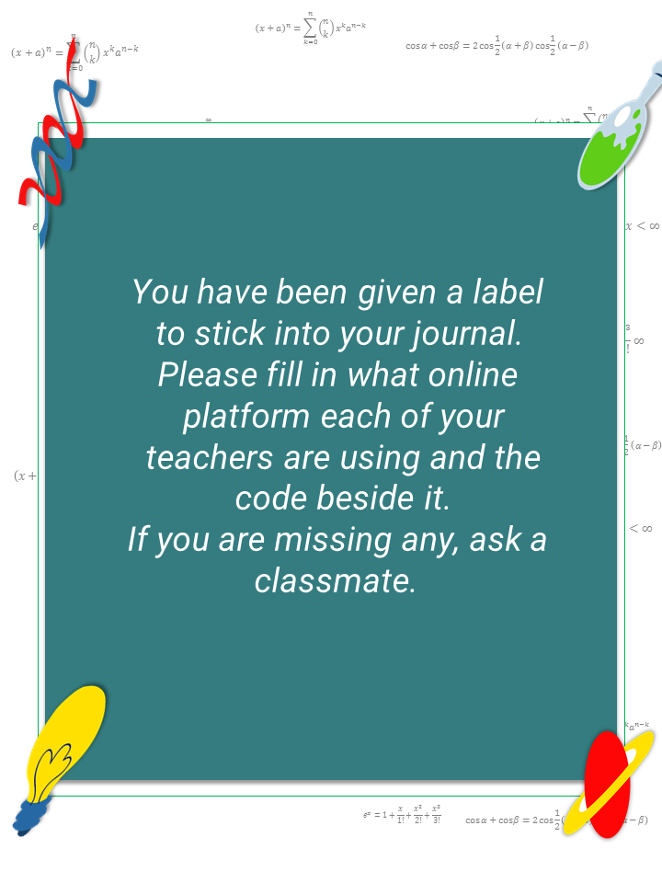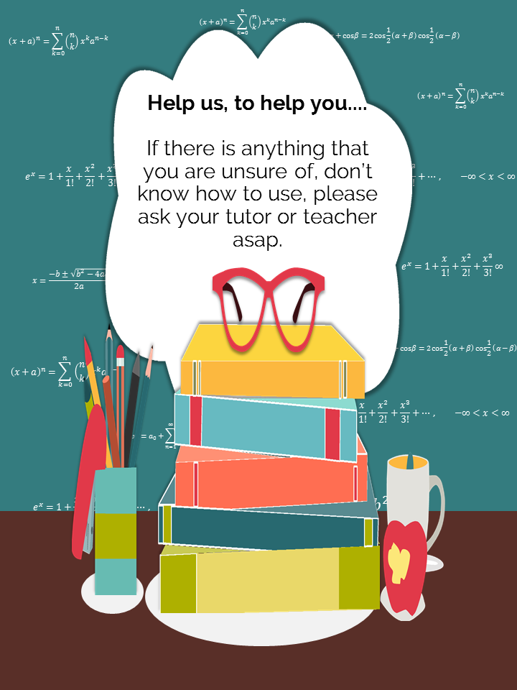

Appenix 2: Edmodo and Team Codes Insert for Student Journals
Junior School Journal Insert:
Subject | Edmodo or Teams? | Edmodo Code
English
Irish
Maths
Spanish/French
History
Geography
Science
Religion
PE
Option 1:
Option 2:

Senior School Junior Insert:
Subject | Edmodo or Teams? | Edmodo Code
English
Irish
Maths
Spanish/French
History
Geography
Science
Religion
PE
Option 1:
Option 2:

Appendix 3: Suggested checklist to support action planning for schools when pupils and/or teachers are advised to self-isolate or restrict their movements
Has an appropriate digital communication platform(s) been selected?
Does it support communication with and between staff?
Does it support communication between staff and pupils?
Does it support communication between schools and parents/guardians?
Does the platform support remote teaching and learning?
Have parents/guardians been notified of contact details during school closures?
Have the relevant skill sets of the staff been identified?
Has a plan for appropriate professional development and support been agreed
where necessary?
Have other relevant staff, for example SNAs, been supported in their relevant digital skills development, to enable them to carry out their role during remote
teaching and learning?
Has a plan for developing pupils skills for remote teaching and learning been agreed, to enable them to:
Access and navigate the platform in use?
Engage with teaching and learning materials?
Upload their own work independently (where age-appropriate to do so)?
Has the school ascertained the availability of digital devices and broadband access
in all households?
Has a plan been put in place to address gaps in the availability of digital devices or
access to broadband?
Has a system for sharing short-term planning and preparation documents,
including plans for pupils with special educational needs, with relevant substitute and other teachers been established?
Is the chairperson of the board of management enabled to access contact details
of staff members and the school inspector in the event that all members of the leadership team are required to self-isolate?
Have parents/guardians been consulted and informed about the platform(s) to be
used during any remote teaching and learning scenarios?
Have procedures for supporting two-way communication and feedback during
remote teaching and learning been established?
Have procedures for communicating with external agencies, including the HSE,
NEPS and NCSE where necessary been established?
Have the following policies been reviewed and updated where necessary?
Acceptable usage policies
Data Protection
Child Safeguarding Statement
Have relevant personnel been identified for each of the possible scenarios outlined
in the guidance document?

