ARDGILLAN PARENT COUNCIL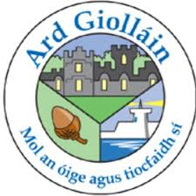
ARE HOLDING A CLOTHING COLLECTION IN THE SCHOOL. BAGS CAN BE DROPPED INTO THE SCHOOL FROM MONDAY 25TH FEBRUARY UNTIL FRIDAY 1ST MARCH .

CASH4YOURCLOTHES.COM
PLEASE FILL A BIN BAG (AS MANY AS YOU LIKE) WITH ANY OF THE FOLLOWING ITEMS:
CLEAN DRY WEARABLE MEN’S WOMEN AND CHILDREN’S CLOTHES, PAIRED SHOES, HANDBAGS, FULL SET OF DUVET COVERS AND PILLOW CASES ONLY, UNWANTED GIFTS, ACCESSORIES, BELTS AND SOFT TOYS.
PLEASE DO NOT INCLUDE ANY OF THE FOLLOWING ITEMS:
QUILTS,PILLOWS, DIRTY OR WET CLOTHING, MATS, CARPETS, OFF CUTS OF MATERIAL, SINGLE SHOES ,SOCKS, MATTRESS COVERS, BLANKETS, UNDERWEAR,TOWELS, CURTAINS AND PLASTIC TOYS.
THANK YOU.

