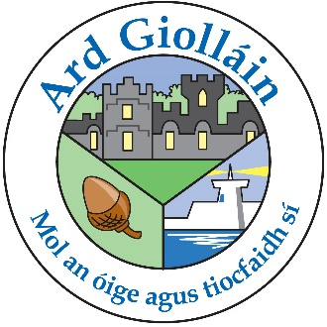

ARDGILLAN PARENT COUNCIL
ARE HOLDING A CLOTHING COLLECTION TO RAISE FUNDS FOR THE SCHOOL. BAGS CAN BE DROPPED INTO THE SCHOOL FROM WEDNESDAY 26thAPRIL TO THURSDAY 4TH MAY. THE BAGS WILL BE COLLECTED FROM THE SCHOOL ON FRIDAY MORNING, 5th MAY.

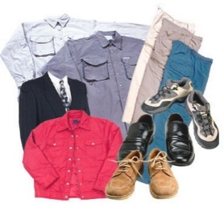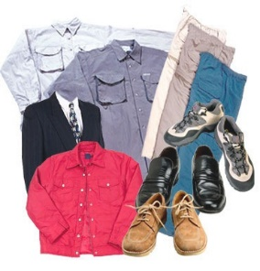
PLEASE FILL BIN BAGS (AS MANY AS YOU LIKE) WITH ANY OF THE FOLLOWING ITEMS:
CLEAN DRY WEARABLE CLOTHES, PAIRED SHOES, HANDBAGS, DUVET COVERS AND PILLOW COVERS, CURTAINS, BELTS AND SOFT TOYS.

PLEASE DO NOT INCLUDE ANY OF THE FOLLOWING ITEMS:
QUILTS, PILLOWS, DIRTY OR WET CLOTHING, MATS, CARPETS, OFF- CUTS OF MATERIAL, SINGLE SHOES, SOCKS, MATTRESS COVERS, BLANKETS, UNDERWEAR, TOWELS AND PLASTIC TOYS.

THANK YOU.

